Drinks at the Urban Oasis

# Apple Sidecar

* 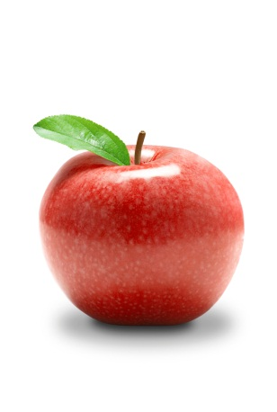2 oz Apple Jack or Calvados
* 4 oz chilled apple cider
* 1 oz amaretto
* Juice of ¼ lemon
* 2 shakes Angostura bitters

Shake over ice.

# Bloody Mary

* 2 oz vodka
* ½ oz lemon juice
* 5 oz Knudsen organic tomato or vegetable juice
* ½ t prepared horseradish
* ¼ t Worcestershire sauce
* 3 shakes Melinda’s jalapeno hot sauce
* ¼ t garlic powder
* 1/8 t salt

This is getting pretty good but it’s still a work in progress

# Grapefruit Basil Gimlet

* 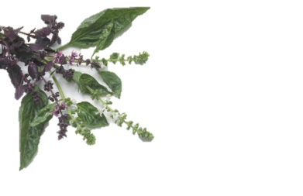1 ½ oz basil simple syrup
* 1 ½ oz vodka
* ½ oz Rose’s lime juice
* 3 ½ - 4 oz grapefruit juice

To make basil simple syrup:

* 2 cups water
* 2 cups sugar
* 3 cups packed basil leaves and the remaining stems, coarsely chopped

Boil the water. Cut the basil leaves and stems into large pieces. Dissolve the sugar in the water and add basil leaves and stems. Turn off heat, cover, and let sit for 30 minutes. Strain into a jar or bottle.

*Kate’s recipe inspired by the Ashmont Grill, Dorchester, MA*

# Margarita

* ½ oz orange liqueur
* 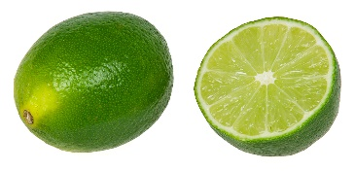1 oz fresh squeezed lime juice
* 1 ½ oz tequila
* salt

Run the lime over the rim of an old fashioned glass and then dip in salt. Add ingredients and ice.

# Margarita (FROZEN)

|  |  |
| --- | --- |
| Serves 2 | Serves 4 |
| 3 oz Frozen Limeaid Concentrate  3 oz Tequila  1 oz Triplesec  3 oz Water  Ice – fill blender to 2 cups | 6 oz Frozen Limeaid Concentrate  6 oz Tequila  2 oz Triplesec  6 oz water Ice – fill blender to 4 cups |

Combine everything except the ice in a blender.  
Blend, adding ice cubes until the drink is slightly slushy.   
It’s best to keep it thinner and not too slushy.

# Mojito

* ½ fresh lime
* 2 oz white rum (Kirk and Sweeney 12 year or 100 Canes preferred)
* 1 oz Simple Syrup (or better, mint simple syrup)
* 6-10 mint leaves
* 5 ice cubes
* Seltzer

Squeeze lime into an old fashioned glass and add the mint leaves and muddle. Then add the rum, simple syrup and ice cubes and stir to chill. Finish by pouring seltzer over top; do not stir the seltzer but just allow the mixing that occurs during a normal pouring.

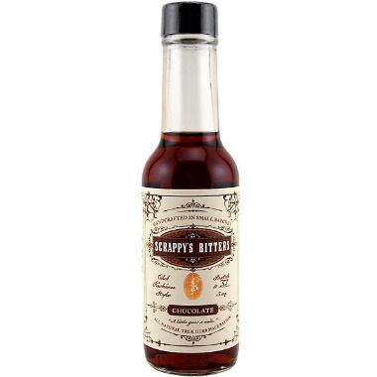Variation: Chocolate Mojito

* ½ oz lemon juice
* 2 oz medium to dark rum (Kirk and Sweeney 12 year rum is good)
* 1 oz simple syrup (or better, mint simple syrup)
* 6-10 mint leaves
* 4 shakes Scrappy’s chocolate bitters

# Sazerac

* ¼ oz Herbsaint
* 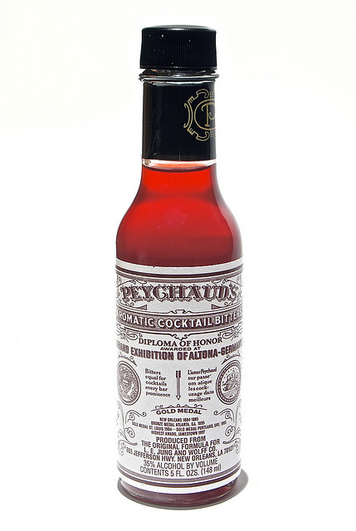2 oz rye whiskey or cognac
* 1/3 oz (2 tsp) simple syrup
* Lemon peel
* 4 shakes Peychaud’s Bitters
* 1 shakes Angostura Bitters

Chill an old fashioned glass by filling it with ice. In a 2nd glass, combine the rye or cognac, simple syrup, and bitters; stir with ice. Remove the ice from the serving glass and coat the inside with Herbsaint. Strain the rye or cognac mixture into the glass and add the lemon. The lemon should be twisted over the glass to release its oils into the mixture.

In 1830, Peychaud created the original concoction with cognac, but in 1870 it began to be served with rye due to a shortage of cognac and a local preference for rye. Restaurant August made this New Orleans signature drink with Sazerac 6-year-old rye. I enjoy it with Redemption Rye, which is especially good for mixing and easier to find.

# Strawberry Daiquiri

|  |  |
| --- | --- |
| Serves 2 | Serves 4 |
| 3 oz rum  1 ½ oz strawberry liqueur  ¼ cup frozen limeade concentrate  ¾ cup frozen strawberries  (whole strawberries loose in glass)  ½ cup loose ice cubes | 6 oz. rum  3 oz strawberry liqueur  ½ cup frozen limeade concentrate  1 ½ cup frozen whole loose strawberries  (overfill 1 cup glass measuring cup to top)  1 cup loose ice cubes |

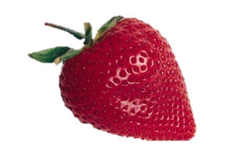Combine everything except the ice in a blender.  
Blend, adding ice cubes until the drink is slightly slushy.   
It’s best to keep it thinner and not too slushy.

# Stone Fence

* 2 oz bourbon
* 4 oz apple cider
* 2 shakes Angistora bitters
* Lemon twist
* Ice

# White Russian

* 1 oz vodka
* 1½ oz Kahlua
* Milk or ½ and ½
* Ice

In an old fashioned glass, mix liquid ingredients with milk or half and half to taste. Add ice to fill. (Hence – half and half will end up with a lot more ice than low fat milk.)

Don’t skimp on the vodka quality too much; the other ingredients won’t cover up cheap vodka. Use Absolut or better.